ASSIGNMENT - 1

User@Amara MINGW64 /e/Git Demo/Gitdemo4 (main)

$ git config --global --list

gui.recentrepo=C:/Users/User/bhavyasri

safe.directory=C:/Users/User

user.name=reddibhavyasri

user.email=reddibhavyasri@gmail.com

core.editor=notepad++.exe -multiInst -nosession

User@Amara MINGW64 /e/Git Demo/Gitdemo4 (main)

$ ls -al

total 4

drwxr-xr-x 1 User 197121 0 Aug 22 20:32 ./

drwxr-xr-x 1 User 197121 0 Aug 22 20:32 ../

drwxr-xr-x 1 User 197121 0 Aug 22 20:37 .git/

User@Amara MINGW64 /e/Git Demo/Gitdemo4 (main)

$ echon"creating new text file">>welcome.txt

bash: echoncreating new text file: command not found

User@Amara MINGW64 /e/Git Demo/Gitdemo4 (main)

$ echo "creating new text file">>welcome.txt

User@Amara MINGW64 /e/Git Demo/Gitdemo4 (main)

$ ls -al

total 5

drwxr-xr-x 1 User 197121 0 Aug 22 20:49 ./

drwxr-xr-x 1 User 197121 0 Aug 22 20:32 ../

drwxr-xr-x 1 User 197121 0 Aug 22 20:37 .git/

-rw-r--r-- 1 User 197121 23 Aug 22 20:50 welcome.txt

User@Amara MINGW64 /e/Git Demo/Gitdemo4 (main)

$ cat welcome.txt

creating new text file

User@Amara MINGW64 /e/Git Demo/Gitdemo4 (main)

$ git status

On branch main

No commits yet

Untracked files:

(use "git add <file>..." to include in what will be committed)

welcome.txt

nothing added to commit but untracked files present (use "git add" to track)

User@Amara MINGW64 /e/Git Demo/Gitdemo4 (main)

$ git add .

warning: in the working copy of 'welcome.txt', LF will be replaced by CRLF the next time Git touches it

User@Amara MINGW64 /e/Git Demo/Gitdemo4 (main)

$ git commit -m "firstcommit"

[main (root-commit) 610f003] firstcommit

1 file changed, 1 insertion(+)

create mode 100644 welcome.txt

User@Amara MINGW64 /e/Git Demo/Gitdemo4 (main)

$ git push origin main

Enumerating objects: 3, done.

Counting objects: 100% (3/3), done.

Writing objects: 100% (3/3), 236 bytes | 236.00 KiB/s, done.

Total 3 (delta 0), reused 0 (delta 0), pack-reused 0

To https://github.com/reddibhavyasri/Gitdemo4.git

* [new branch] main -> main

User@Amara MINGW64 /e/Git Demo/Gitdemo4 (main)

$ git pull origin main

From https://github.com/reddibhavyasri/Gitdemo4

* branch main -> FETCH_HEAD

Already up to date.

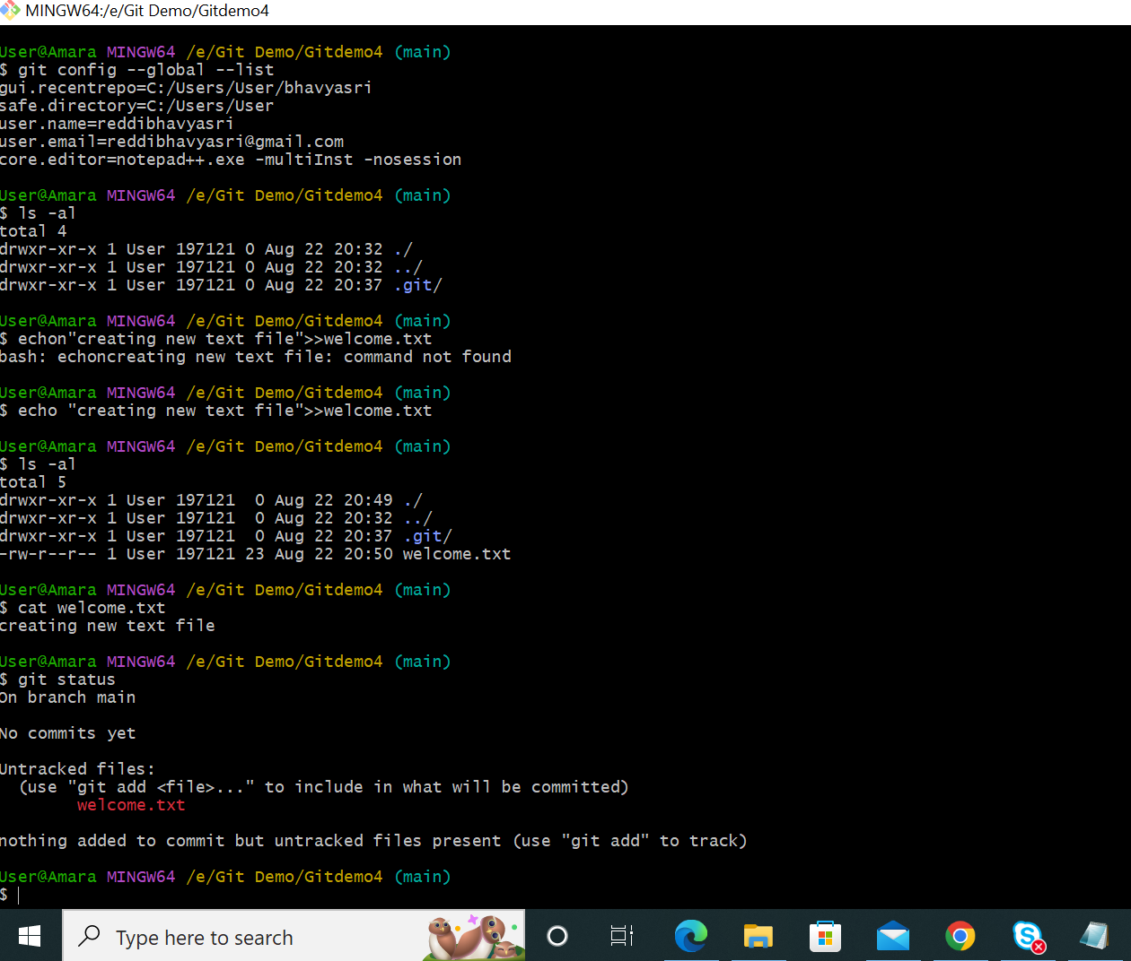

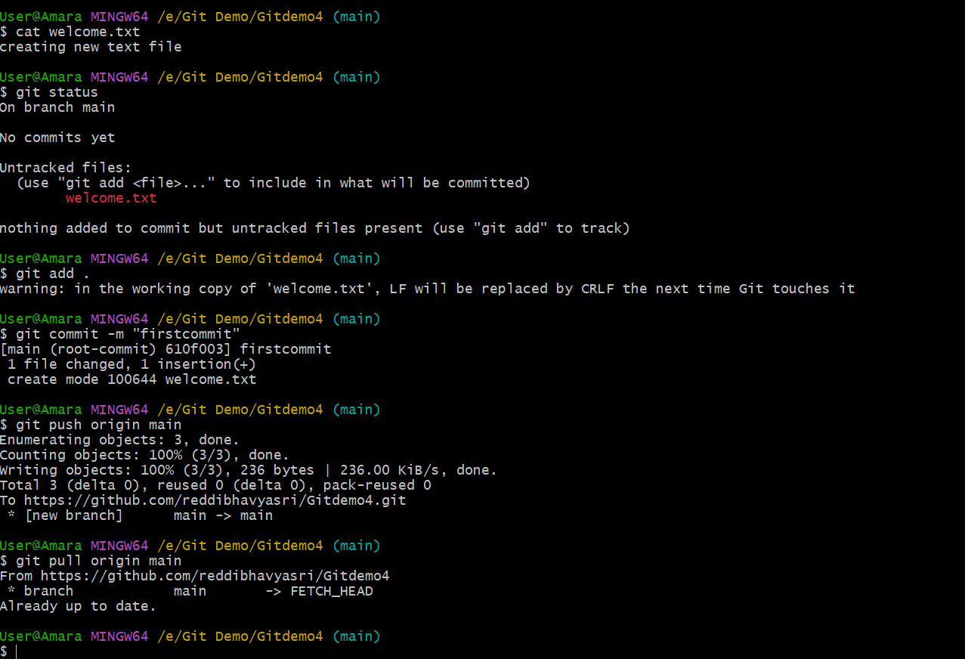

ASSIGNMENT – 2

User@Amara MINGW64 /e/Git Demo/Gitdemo4 (main)

$ touch .gitignore

User@Amara MINGW64 /e/Git Demo/Gitdemo4 (main)

$ cat .gitignore

User@Amara MINGW64 /e/Git Demo/Gitdemo4 (main)

$ cat .gitignore

User@Amara MINGW64 /e/Git Demo/Gitdemo4 (main)

$ cat .gitignore

*.log

/new folder/*

User@Amara MINGW64 /e/Git Demo/Gitdemo4 (main)

$ git add

Nothing specified, nothing added.

hint: Maybe you wanted to say 'git add .'?

hint: Turn this message off by running

hint: "git config advice.addEmptyPathspec false"

User@Amara MINGW64 /e/Git Demo/Gitdemo4 (main)

$ git add .

User@Amara MINGW64 /e/Git Demo/Gitdemo4 (main)

$ git status

On branch main

Your branch is up to date with 'origin/main'.

Changes to be committed:

(use "git restore --staged <file>..." to unstage)

new file: .gitignore

User@Amara MINGW64 /e/Git Demo/Gitdemo4 (main)

$ touch sample.log

User@Amara MINGW64 /e/Git Demo/Gitdemo4 (main)

$ cat sample.log

User@Amara MINGW64 /e/Git Demo/Gitdemo4 (main)

$ git add .

User@Amara MINGW64 /e/Git Demo/Gitdemo4 (main)

$ git commit -m "gitignore"

[main 2f91afc] gitignore

1 file changed, 2 insertions(+)

create mode 100644 .gitignore

User@Amara MINGW64 /e/Git Demo/Gitdemo4 (main)

$ git push origin main

Enumerating objects: 4, done.

Counting objects: 100% (4/4), done.

Delta compression using up to 4 threads

Compressing objects: 100% (2/2), done.

Writing objects: 100% (3/3), 296 bytes | 296.00 KiB/s, done.

Total 3 (delta 0), reused 0 (delta 0), pack-reused 0

To https://github.com/reddibhavyasri/Gitdemo4.git

610f003..2f91afc main -> main

User@Amara MINGW64 /e/Git Demo/Gitdemo4 (main)

$ echo "this is an example">>sample.log

User@Amara MINGW64 /e/Git Demo/Gitdemo4 (main)

$ cat sample.log

this is an example

User@Amara MINGW64 /e/Git Demo/Gitdemo4 (main)

$

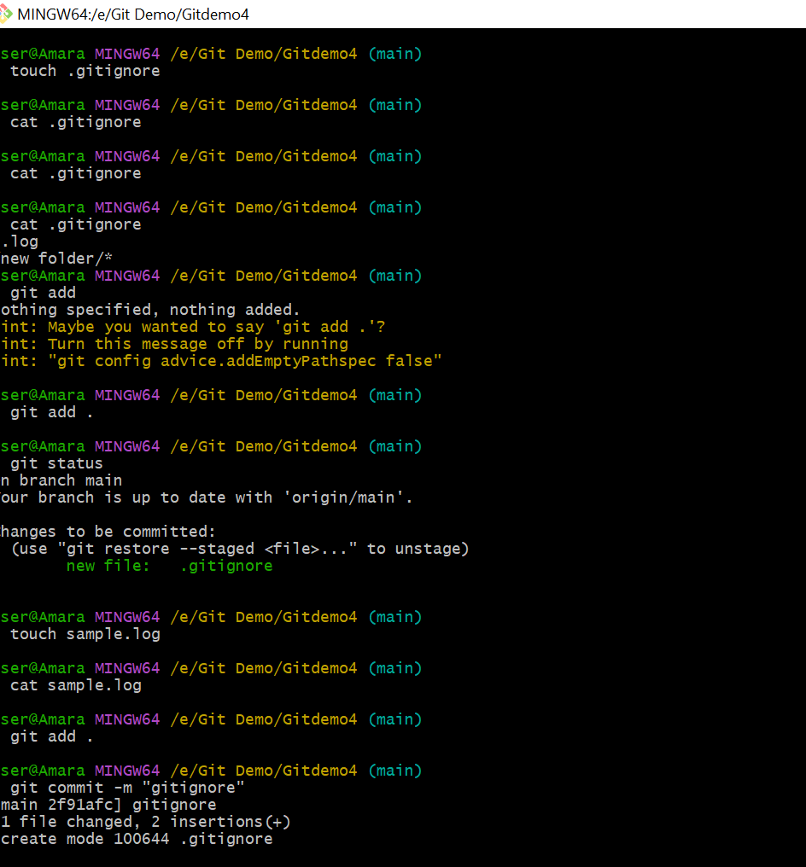

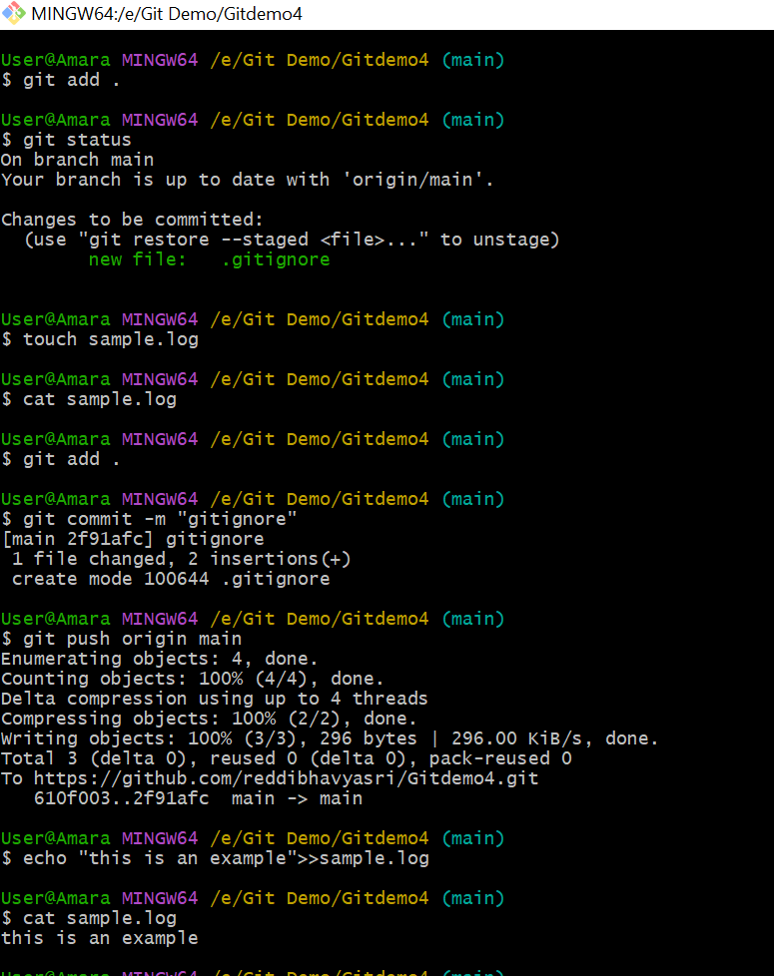

ASSIGNMENT -3

User@Amara MINGW64 /e/Git Demo/Gitdemo4 (main)

$ git branch

* main

User@Amara MINGW64 /e/Git Demo/Gitdemo4 (main)

$ git branch branch1

User@Amara MINGW64 /e/Git Demo/Gitdemo4 (main)

$ git branch

branch1

* main

User@Amara MINGW64 /e/Git Demo/Gitdemo4 (main)

$ git checkout branch1

Switched to branch 'branch1'

User@Amara MINGW64 /e/Git Demo/Gitdemo4 (branch1)

$ touch hello.txt

User@Amara MINGW64 /e/Git Demo/Gitdemo4 (branch1)

$ echo "Adding file to the new branch">>hello.txt

User@Amara MINGW64 /e/Git Demo/Gitdemo4 (branch1)

$ git add .

warning: in the working copy of 'hello.txt', LF will be replaced by CRLF the next time Git touches it

User@Amara MINGW64 /e/Git Demo/Gitdemo4 (branch1)

$ git commit -m "newcommit"

[branch1 1b1dafc] newcommit

1 file changed, 1 insertion(+)

create mode 100644 hello.txt

User@Amara MINGW64 /e/Git Demo/Gitdemo4 (branch1)

$ git status

On branch branch1

nothing to commit, working tree clean

User@Amara MINGW64 /e/Git Demo/Gitdemo4 (branch1)

$ git push origin branch1

Enumerating objects: 4, done.

Counting objects: 100% (4/4), done.

Delta compression using up to 4 threads

Compressing objects: 100% (2/2), done.

Writing objects: 100% (3/3), 336 bytes | 336.00 KiB/s, done.

Total 3 (delta 0), reused 0 (delta 0), pack-reused 0

remote:

remote: Create a pull request for 'branch1' on GitHub by visiting:

remote: https://github.com/reddibhavyasri/Gitdemo4/pull/new/branch1

remote:

To https://github.com/reddibhavyasri/Gitdemo4.git

* [new branch] branch1 -> branch1

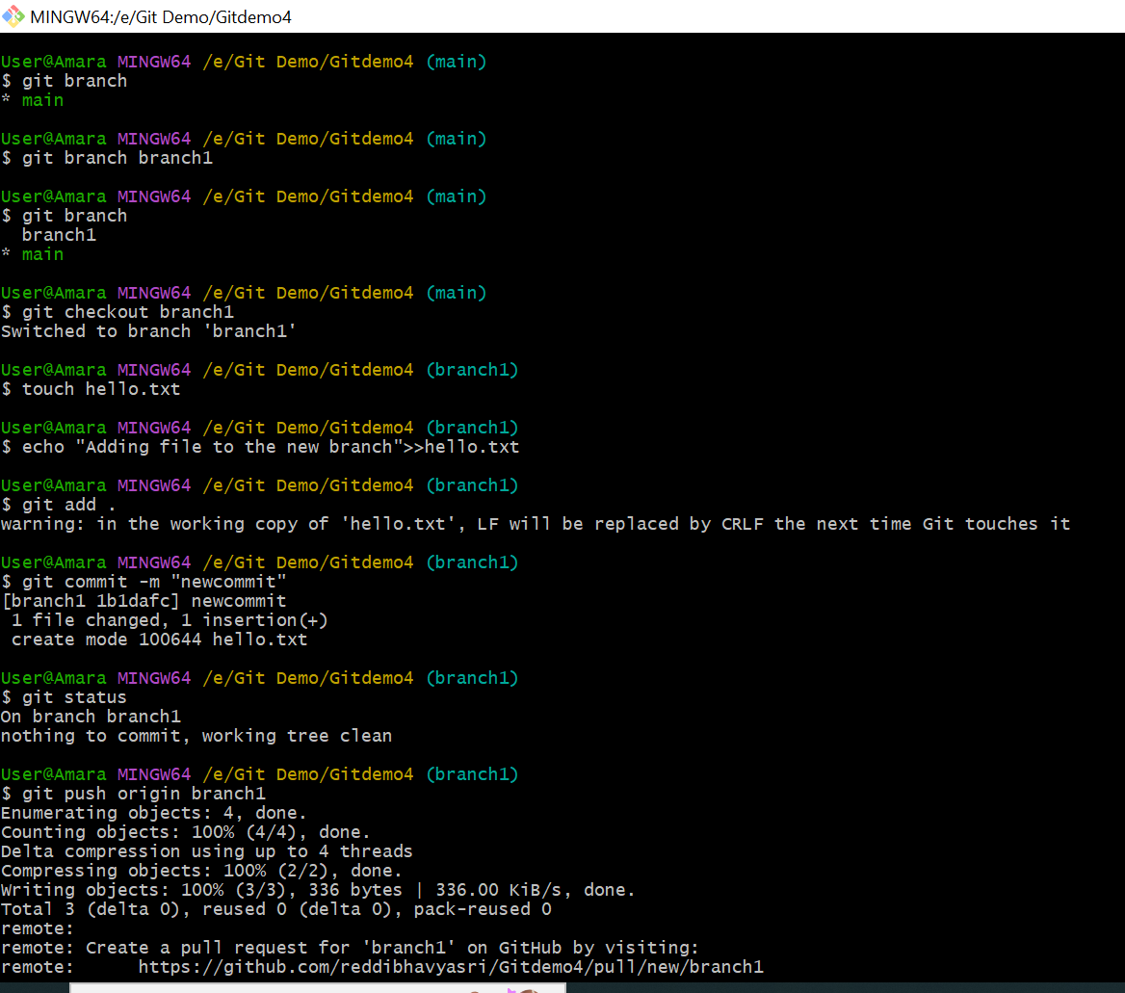

MERGING

User@Amara MINGW64 /e/Git Demo/Gitdemo4 (branch1)

$ git log --oneline --graph --decorate

* 1b1dafc (HEAD -> branch1, origin/branch1) newcommit

* 2f91afc (origin/main, main) gitignore

* 610f003 firstcommit

User@Amara MINGW64 /e/Git Demo/Gitdemo4 (branch1)

$ git checkout brancg1

error: pathspec 'brancg1' did not match any file(s) known to git

User@Amara MINGW64 /e/Git Demo/Gitdemo4 (branch1)

$ git checkout branch1

Already on 'branch1'

User@Amara MINGW64 /e/Git Demo/Gitdemo4 (branch1)

$ git log --oneline --graph --decorate

* 1b1dafc (HEAD -> branch1, origin/branch1) newcommit

* 2f91afc (origin/main, main) gitignore

* 610f003 firstcommit

User@Amara MINGW64 /e/Git Demo/Gitdemo4 (branch1)

$ git checkout main

Switched to branch 'main'

Your branch is up to date with 'origin/main'.

User@Amara MINGW64 /e/Git Demo/Gitdemo4 (main)

$ git merge branch1

Updating 2f91afc..1b1dafc

Fast-forward

hello.txt | 1 +

1 file changed, 1 insertion(+)

create mode 100644 hello.txt

User@Amara MINGW64 /e/Git Demo/Gitdemo4 (main)

$ git log --oneline --graph --decorate

* 1b1dafc (HEAD -> main, origin/branch1, branch1) newcommit

* 2f91afc (origin/main) gitignore

* 610f003 firstcommit

User@Amara MINGW64 /e/Git Demo/Gitdemo4 (main)

$

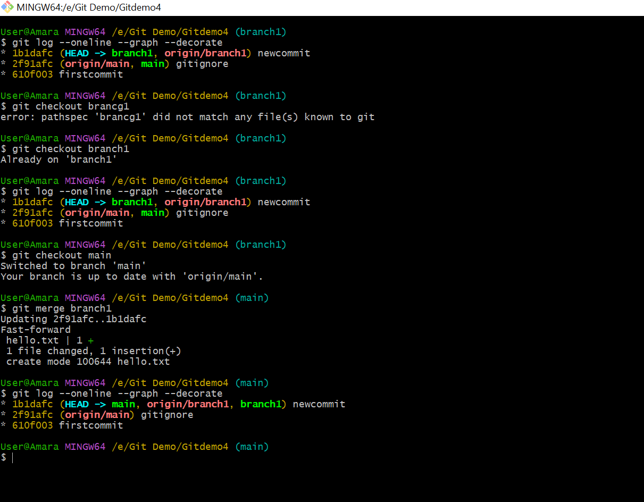

DELETING

User@Amara MINGW64 /e/Git Demo/Gitdemo4 (main)

$ git branch -d branch1

Deleted branch branch1 (was 1b1dafc).

User@Amara MINGW64 /e/Git Demo/Gitdemo4 (main)

$ git push origin --delete branch1

To https://github.com/reddibhavyasri/Gitdemo4.git

- [deleted] branch1

User@Amara MINGW64 /e/Git Demo/Gitdemo4 (main)

$ git add .

User@Amara MINGW64 /e/Git Demo/Gitdemo4 (main)

$ git commit -m "deleting branch"

On branch main

Your branch is ahead of 'origin/main' by 1 commit.

(use "git push" to publish your local commits)

nothing to commit, working tree clean

User@Amara MINGW64 /e/Git Demo/Gitdemo4 (main)

$ git push origin main

Enumerating objects: 4, done.

Counting objects: 100% (4/4), done.

Delta compression using up to 4 threads

Compressing objects: 100% (2/2), done.

Writing objects: 100% (3/3), 336 bytes | 336.00 KiB/s, done.

Total 3 (delta 0), reused 0 (delta 0), pack-reused 0

To https://github.com/reddibhavyasri/Gitdemo4.git

2f91afc..1b1dafc main -> main

User@Amara MINGW64 /e/Git Demo/Gitdemo4 (main)

$ git status

On branch main

Your branch is up to date with 'origin/main'.

nothing to commit, working tree clean

User@Amara MINGW64 /e/Git Demo/Gitdemo4 (main)

$ git branch

* main

User@Amara MINGW64 /e/Git Demo/Gitdemo4 (main)

$

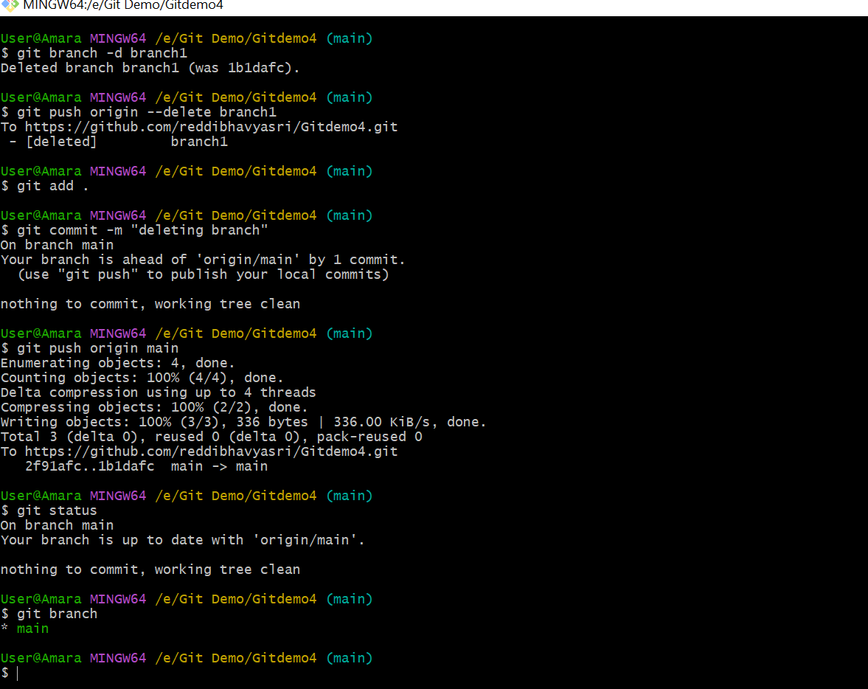

ASSIGNMENT – 4

User@Amara MINGW64 /e/Git Demo/Gitdemo4 (main)

$ git status

On branch main

Your branch is up to date with 'origin/main'.

nothing to commit, working tree clean

User@Amara MINGW64 /e/Git Demo/Gitdemo4 (main)

$ git branch gitWork

User@Amara MINGW64 /e/Git Demo/Gitdemo4 (main)

$ git checkout gitWork

Switched to branch 'gitWork'

User@Amara MINGW64 /e/Git Demo/Gitdemo4 (gitWork)

$ touch hello.xml

User@Amara MINGW64 /e/Git Demo/Gitdemo4 (gitWork)

$ git add .

User@Amara MINGW64 /e/Git Demo/Gitdemo4 (gitWork)

$ cat hello.xml

User@Amara MINGW64 /e/Git Demo/Gitdemo4 (gitWork)

$ cat hello.xml

<book>

<authour>rani</authour>

<title>Natural thoughts</title>

<type>natural</type>

<country>canada</country>

</book>

User@Amara MINGW64 /e/Git Demo/Gitdemo4 (gitWork)

$ git status

On branch gitWork

Changes to be committed:

(use "git restore --staged <file>..." to unstage)

new file: hello.xml

Changes not staged for commit:

(use "git add <file>..." to update what will be committed)

(use "git restore <file>..." to discard changes in working directory)

modified: hello.xml

User@Amara MINGW64 /e/Git Demo/Gitdemo4 (gitWork)

$ git commit -m "commiting from main"

[gitWork f7f01f0] commiting from main

1 file changed, 0 insertions(+), 0 deletions(-)

create mode 100644 hello.xml

User@Amara MINGW64 /e/Git Demo/Gitdemo4 (gitWork)

$ git checkout main

error: Your local changes to the following files would be overwritten by checkout:

hello.xml

Please commit your changes or stash them before you switch branches.

Aborting

User@Amara MINGW64 /e/Git Demo/Gitdemo4 (gitWork)

$ git checkout main

error: Your local changes to the following files would be overwritten by checkout:

hello.xml

Please commit your changes or stash them before you switch branches.

Aborting

User@Amara MINGW64 /e/Git Demo/Gitdemo4 (gitWork)

$ touch hello.xml

User@Amara MINGW64 /e/Git Demo/Gitdemo4 (gitWork)

$ cat hello.xml

<book>

<authour>rani</authour>

<title>Natural thoughts</title>

<type>natural</type>

<country>canada</country>

</book>

User@Amara MINGW64 /e/Git Demo/Gitdemo4 (gitWork)

$ git commit -m "commiting from main"

On branch gitWork

Changes not staged for commit:

(use "git add <file>..." to update what will be committed)

(use "git restore <file>..." to discard changes in working directory)

modified: hello.xml

no changes added to commit (use "git add" and/or "git commit -a")

User@Amara MINGW64 /e/Git Demo/Gitdemo4 (gitWork)

$ git checkout main

error: Your local changes to the following files would be overwritten by checkout:

hello.xml

Please commit your changes or stash them before you switch branches.

Aborting

User@Amara MINGW64 /e/Git Demo/Gitdemo4 (gitWork)

$ git commit

On branch gitwork

nothing to commit, working tree clean

User@Amara MINGW64 /e/Git Demo/Gitdemo4 (gitwork)

$ git checkout main

Switched to branch 'main'

Your branch is up to date with 'origin/main'.

User@Amara MINGW64 /e/Git Demo/Gitdemo4 (main)

$ git add .

User@Amara MINGW64 /e/Git Demo/Gitdemo4 (main)

$ touch hello.xml

User@Amara MINGW64 /e/Git Demo/Gitdemo4 (main)

$ cat hello.xml

User@Amara MINGW64 /e/Git Demo/Gitdemo4 (main)

$ cat hello.xml

<fruit>

<tree>orange</tree>

<flower>pretty</flower>

<taste>sweet</taste>

</fruit>

User@Amara MINGW64 /e/Git Demo/Gitdemo4 (main)

$ git commit -m"from main branch"

On branch main

Your branch is up to date with 'origin/main'.

Untracked files:

(use "git add <file>..." to include in what will be committed)

hello.xml

nothing added to commit but untracked files present (use "git add" to track)

User@Amara MINGW64 /e/Git Demo/Gitdemo4 (main)

$ git add .

User@Amara MINGW64 /e/Git Demo/Gitdemo4 (main)

$ git commit -m"commitimg from main branch"

[main 8156975] commitimg from main branch

1 file changed, 5 insertions(+)

create mode 100644 hello.xml

User@Amara MINGW64 /e/Git Demo/Gitdemo4 (main)

$ git log --oneline --graph --decorate

* 8156975 (HEAD -> main) commitimg from main branch

* 1b1dafc (origin/main) newcommit

* 2f91afc gitignore

* 610f003 firstcommit

User@Amara MINGW64 /e/Git Demo/Gitdemo4 (main)

$ git log --oneline --graph --decorate --all

* 8156975 (HEAD -> main) commitimg from main branch

| * 62c2feb (gitwork) commiting from main branch

| * 64eb746 committing from main

| * f7f01f0 commiting from main

|/

* 1b1dafc (origin/main) newcommit

* 2f91afc gitignore

* 610f003 firstcommit

User@Amara MINGW64 /e/Git Demo/Gitdemo4 (main)

$ git diff gitwork main

diff --git a/hello.txt b/hello.txt

new file mode 100644

index 0000000..ff037bd

--- /dev/null

+++ b/hello.txt

@@ -0,0 +1 @@

+Adding file to the new branch

diff --git a/hello.xml b/hello.xml

index c9f93dc..aa607b9 100644

--- a/hello.xml

+++ b/hello.xml

@@ -1,5 +1,5 @@

-<book>

-<writer>abcu</writer>

-<title>natural thoughts</title>

-<content>natural</content>

-</book>

\ No newline at end of file

+<fruit>

+<tree>orange</tree>

+<flower>pretty</flower>

+<taste>sweet</taste>

+</fruit>

\ No newline at end of file

User@Amara MINGW64 /e/Git Demo/Gitdemo4 (main)

$

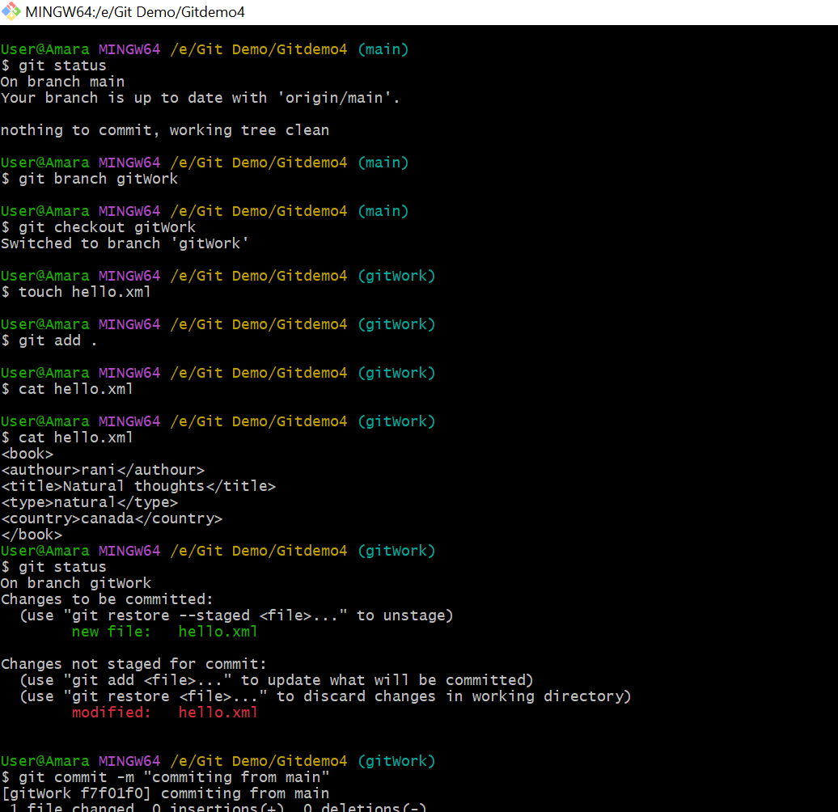

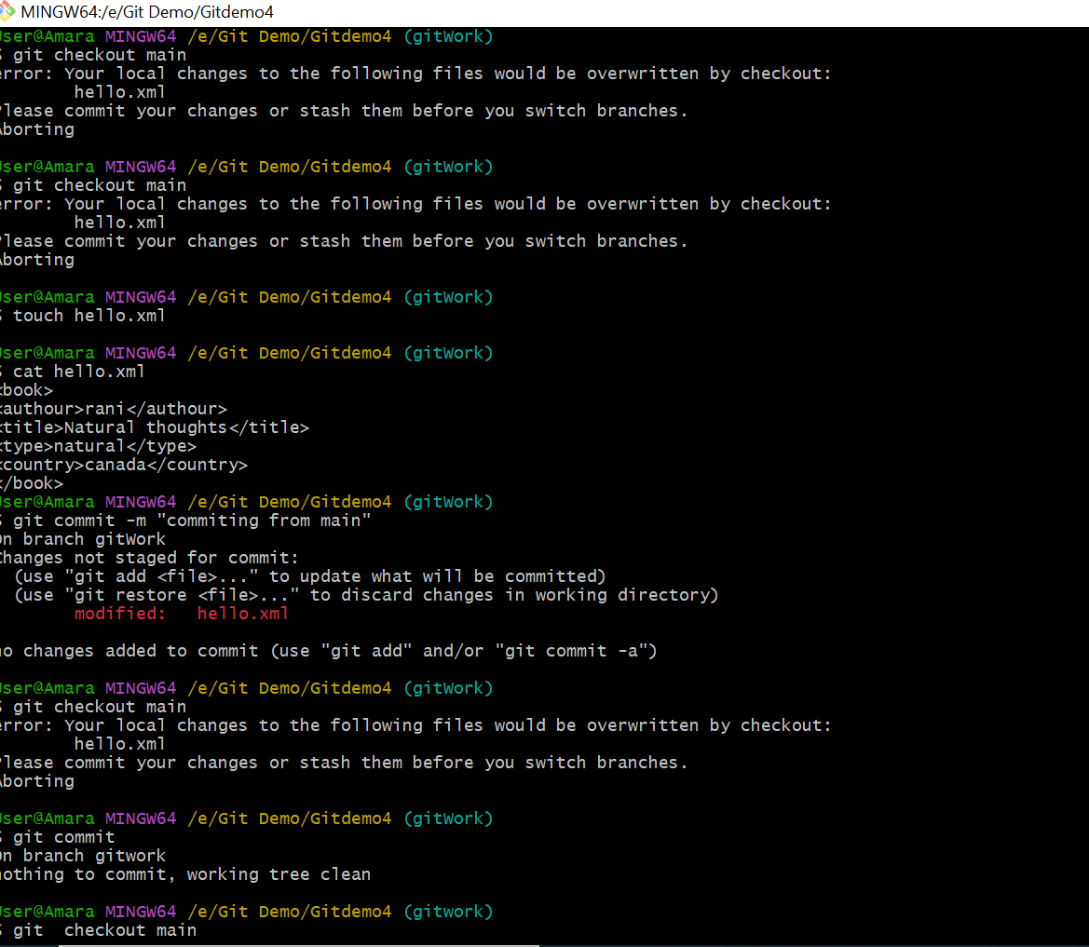

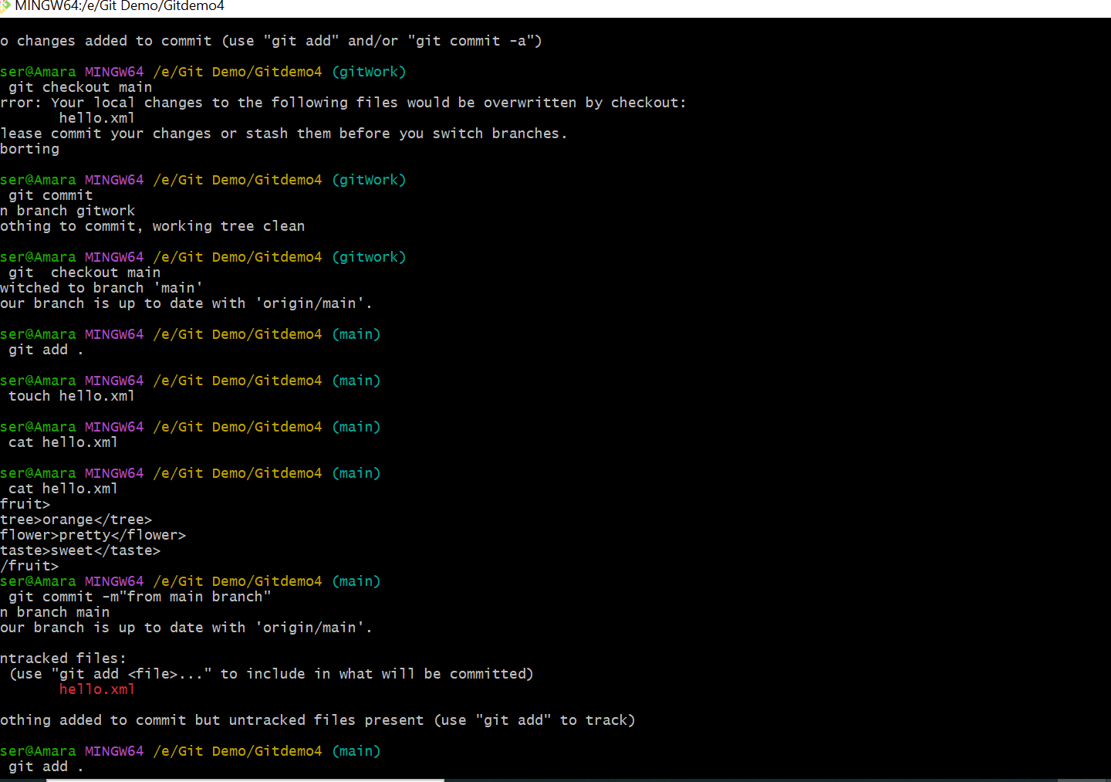

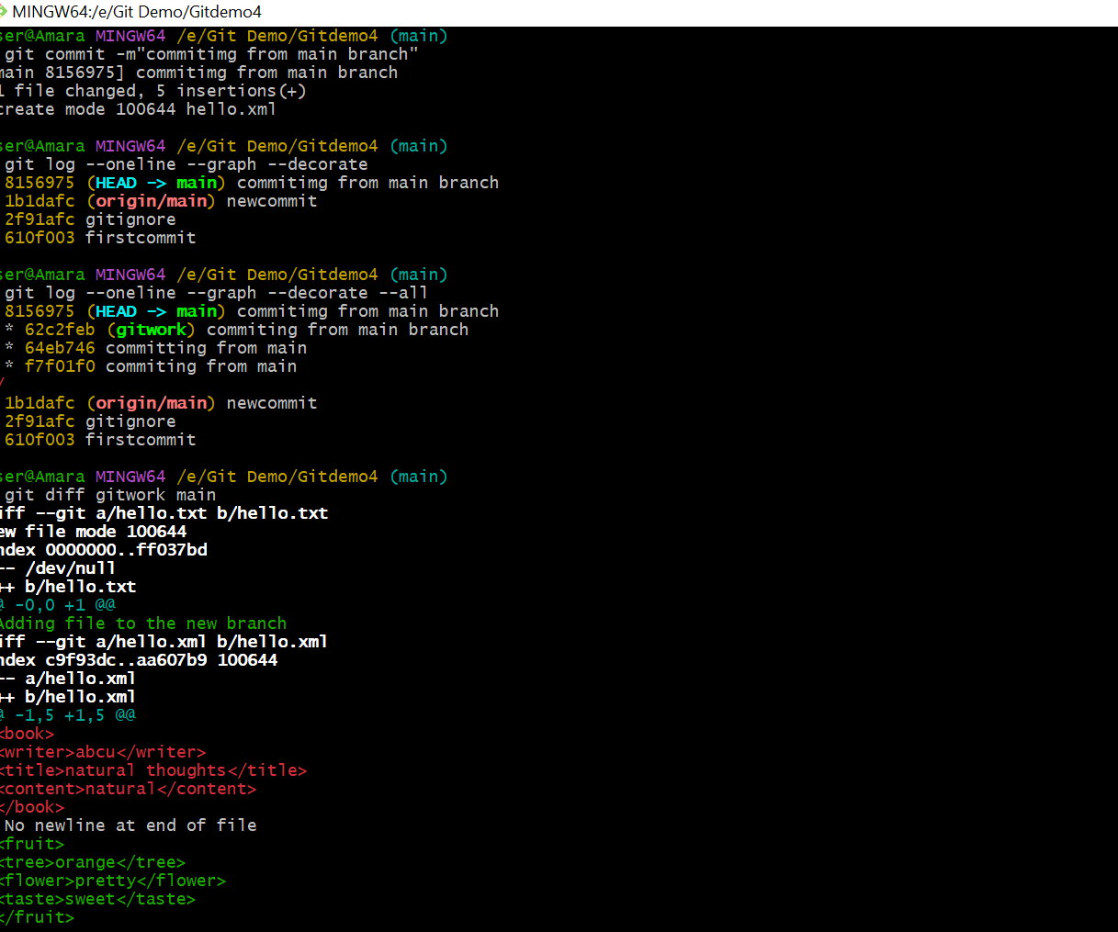

ASSIGNMENT -5

User@Amara MINGW64 /e/Git Demo/Gitdemo4 (main)

$ git status

On branch main

Your branch is ahead of 'origin/main' by 1 commit.

(use "git push" to publish your local commits)

nothing to commit, working tree clean

User@Amara MINGW64 /e/Git Demo/Gitdemo4 (main)

$ git push origin main

Enumerating objects: 4, done.

Counting objects: 100% (4/4), done.

Delta compression using up to 4 threads

Compressing objects: 100% (3/3), done.

Writing objects: 100% (3/3), 406 bytes | 406.00 KiB/s, done.

Total 3 (delta 0), reused 0 (delta 0), pack-reused 0

To https://github.com/reddibhavyasri/Gitdemo4.git

1b1dafc..8156975 main -> main

User@Amara MINGW64 /e/Git Demo/Gitdemo4 (main)

$ git pull origin main

From https://github.com/reddibhavyasri/Gitdemo4

* branch main -> FETCH_HEAD

Already up to date.

User@Amara MINGW64 /e/Git Demo/Gitdemo4 (main)

$ git branch

gitwork

* main

User@Amara MINGW64 /e/Git Demo/Gitdemo4 (main)

$ git diff main gitwork

diff --git a/hello.txt b/hello.txt

deleted file mode 100644

index ff037bd..0000000

--- a/hello.txt

+++ /dev/null

@@ -1 +0,0 @@

-Adding file to the new branch

diff --git a/hello.xml b/hello.xml

index aa607b9..c9f93dc 100644

--- a/hello.xml

+++ b/hello.xml

@@ -1,5 +1,5 @@

-<fruit>

-<tree>orange</tree>

-<flower>pretty</flower>

-<taste>sweet</taste>

-</fruit>

\ No newline at end of file

+<book>

+<writer>abcu</writer>

+<title>natural thoughts</title>

+<content>natural</content>

+</book>

\ No newline at end of file

User@Amara MINGW64 /e/Git Demo/Gitdemo4 (main)

$

